**REACT TYPESCRIPT PROJECT INITIALIZATION**

# **Project Setup:**

Run the following command to generate your React Typescript application:

*npx create-react-app <your-app-name > --template typescript*

# **React Component Type:**

The type **React.FC**  indicates that this function is not a normal function it is a React functional component that must return JSX.

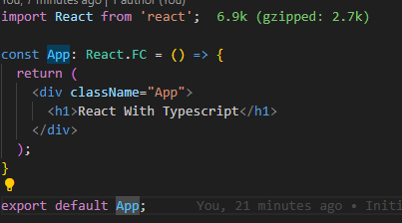

The **React.FC<{}>** is also an generic type that allows us to define the types of props that we are going tom receive.

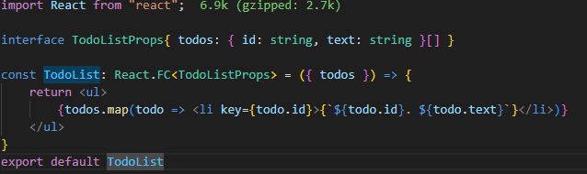

# **React Events:**

* The Form Submission event type in react is **React.FormEvent.**

